What should I title this??
What should you do when a problem is too large or complex to understand?
Two good options are:
(1) Figure out how to break it into smaller pieces and look at the pieces separately
(2) Explore smaller examples to find a pattern

Let’s try out these ideas on a warm-up problem.

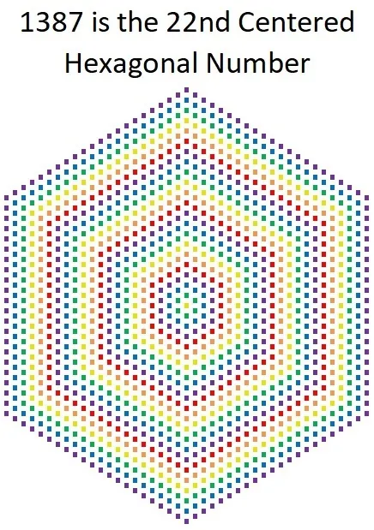
How many dots total?
1). Try using strategy 1 (break the problem into smaller pieces) to more easily figure out the total number of dots.

2). In math we’re always hoping whatever we do to understand one answer will also let as easily answer larger or related questions.
Let’s test how powerful your approach in #1 was. Can you use it to quickly decide how many dots there would be if there were 100 dots along each outer side?

3). If you’d like, try and answer questions 1 and 2 by breaking the problem into different pieces and see if your resulting method seems easier or harder.

Ok. Now let’s look at what it would look like to try method 2: exploring smaller examples of the same problem to find a pattern. Before I walk you through it, predict…
4). What would be an example of a smaller version of this problem? What’s the smallest possible version of this problem? What if you made it one larger? What if you made it one larger?

Here’s the approach I have in mind.
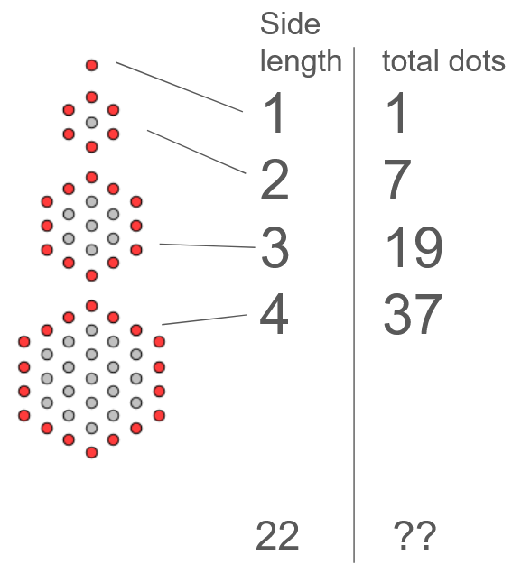
The original question is asking about the total dots when there are 22 dots on a side.
You can image that answer as fitting into a sequence of answers for larger and larger versions of the problem.
When the problem is small, you can literally just count all the dots.
If there was some pattern in the answers, you could (hopefully!) jump straight to the answer you want. Or the answer to side length 100, or any other answer.

Now you know (if you didn’t before) how to recognize what type of growth might be happening.
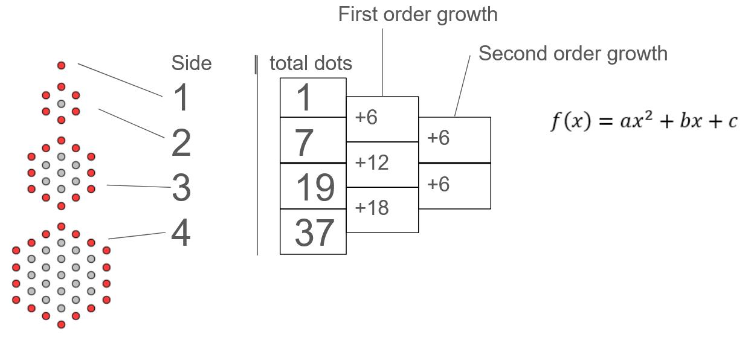
If you know the second order growth is constant, you can model the data using a quadratic function. The whole trick now is to figure out values for a, b, and c which fit the data you have.
One way to do it is to plug in three sets of (x, y) values to $y=ax^{2}+bx+c$ and then solve for what values of a, b and c make those equations true.
There are often shorter or easier things you can do, depending on the problem – that’s up to you to try and spot – but this approach will always work.
Here’s what it looks like to do…
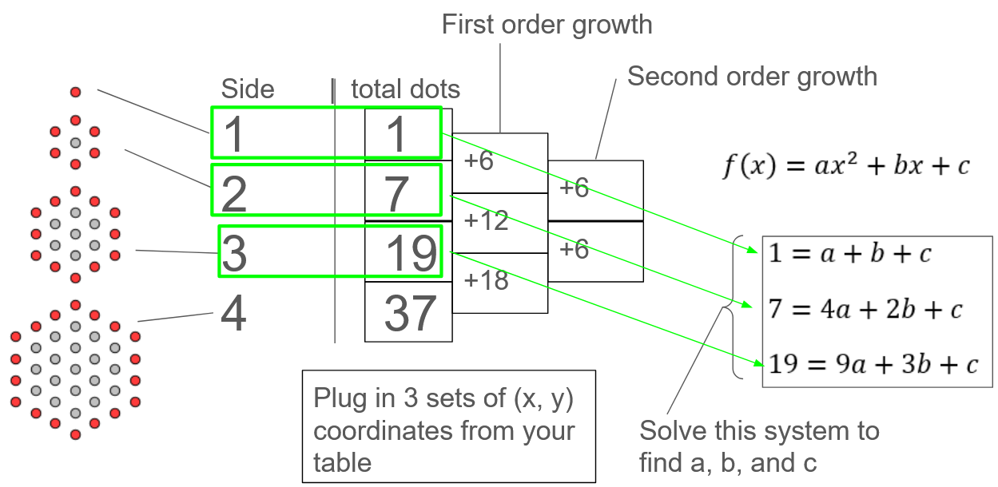
Plugging in the first three rows gave me three equations. Now I can use elimination to solve for the unknown parameters.
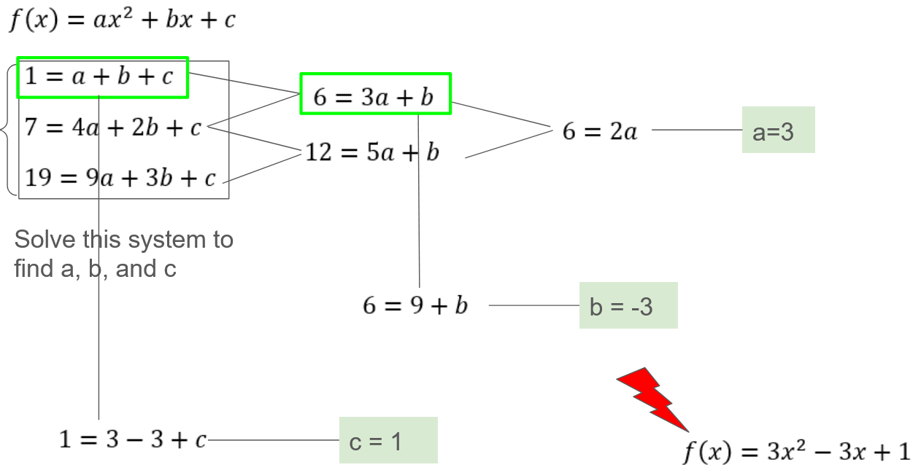
Finding the function $f(x)$ has let us solve all versions of this problem at once.
Now you can answer the original problem by finding $f(22)$. You can find the total dots for a shape with 100 dots on a side by finding $f(100)$.
Knowing the equation also tells you other things. You could easily answer the question: “If I wanted to make this out of pennies, what’s the largest shape like this I could make if I had 7000 pennies?”.
Wrapping it up

Write out the high-level plan we followed to answer the origial question.
What strategy were we using? What did we do first? What did we do next?
Write out the steps from start to finish so you can use this general approach on other problems.

Problems
Try out the “explore small examples to find a pattern” strategy on these problems. Do as many or as few as you want in any order.
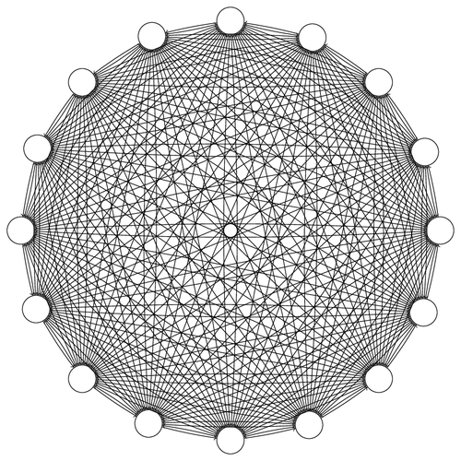
Handshakes.
Here's a picture of 16 people, all shaking hands with each other. As you can see, each dot is a person, and each line represents a handshake between the two people it connects.

Let’s define H(n) to be the number of total handshakes between n people.

Use the “explore small examples” strategy to find H(16), H(2120), and H(n) in general.

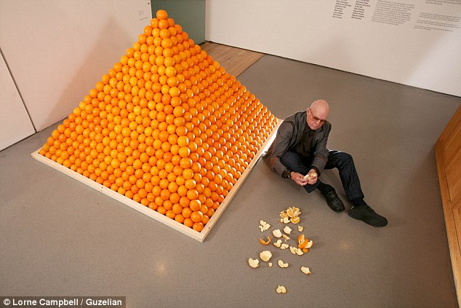
Oranges.
Here’s a square-base pyramid of oranges with 22 oranges along the length of each side on the base.
Define O(b) to represent the total oranges in a pyramid with a base side-length of b. Determine O(22), O(50) and O(n) in general.

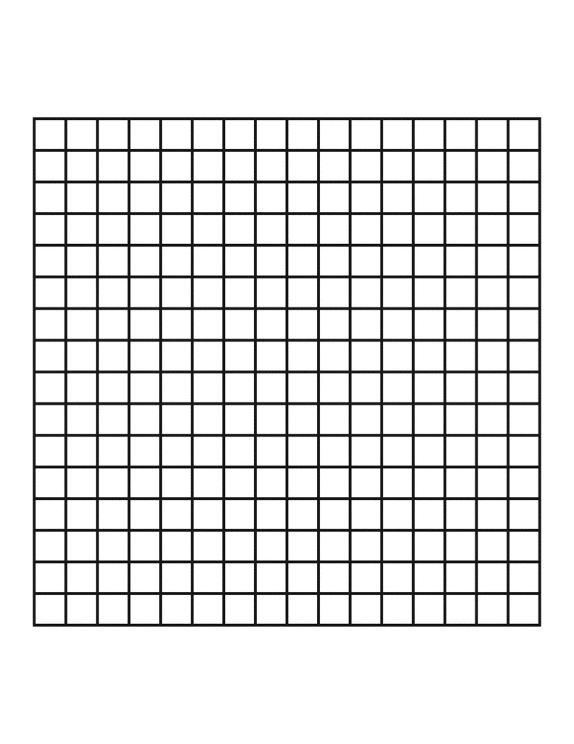
Squares.
Here’s a 16 x 16 grid. How many total (grid aligned) squares of any size can you make from the lines? (I’ve highlighted a few to show you some examples of what you’re counting)
Let S(n) be the total number of all the different sizes of square in an n by n grid. Find S(16), S(100) and S(n) in general.

Maximum Regions.
With 9 straight lines, I can create different numbers of regions in a square, depending on how they’re arranged.
Here are examples where 9 lines can make 18 regions, or 30 (?) regions.
What’s the largest number of regions I can make with 100 lines? With 200 lines?
Let $R(n)$ represent the maximum number of regions possible with n lines. Find R(100), R(200) and R(n) in general.
A tricky part of this problem is providing a convincing reason that the numbers in your table really represent the maximum regions possible.

Rectangles.
Here’s a 16 x 16 grid. How many total (grid aligned) rectangles of any size can you make from the lines? Note that a square is a special kind of rectangle (one whose width and height are equal); so squares will count in the rectangles you’re counting.
Let R(n) be the total number of all the different sizes of square in an n by n grid. Find R(16), R(100) and R(n) in general.
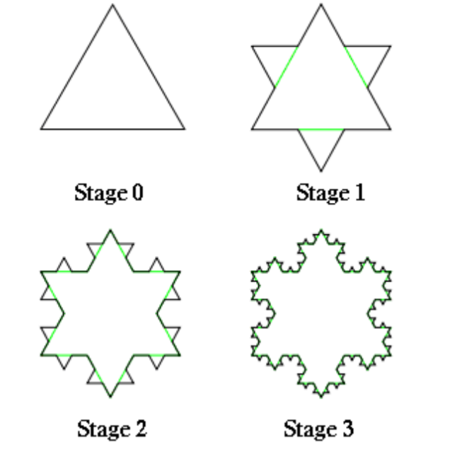
Snowflakes.
Make a Stage n snowflake this way:
Start with an equilateral triangle, all sides length 1.
Remove the middle third of each side and replace it with two lines that form an equilateral triangle with the removed piece.
Repeat this process for the all sides n times.
There are several realted things you could find:
Let $P(n)$ be the perimieter of a stage n snowflake. Let S(n) represent the number of sides of a stage n snowflake, and let $A(n)$ represent the area of a stage n snowflake. Find any or all of these functions.

